**Twitter Key setup for twitter search**

To use the commerical version of twitter, I have subscribed to Twitter “Premium” account, as twitter’s setup will change, below is a guidance on how to prepare the necessary key. For most up to date guidance, best to consult<https://pypi.org/project/searchtweets/1.0/>

1. Create the key file called .twitter_keys.yaml and save under Home directory of your account

the following in <> are to be filled in subsequent steps.

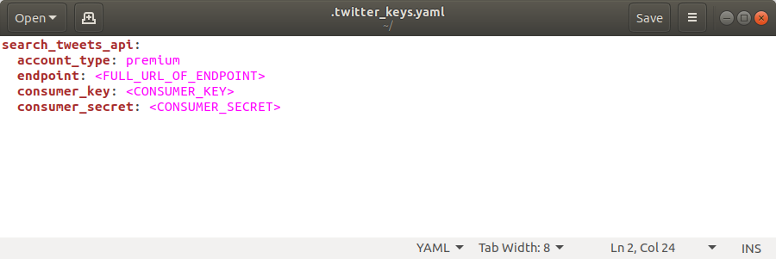

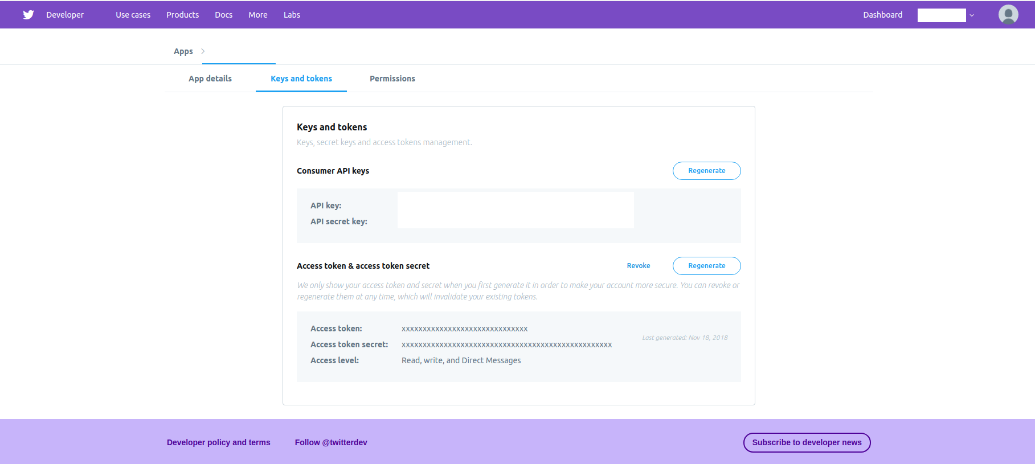2. Fill up the key and secret, which could be obtained from the twitter developer account’s keys and tokens as Consumer Key and Consumer Secret

3. Find out the tweeter search endpoint:

It’s a combination of 3 components in this format:

[Basic URL][product name][development environment].json, such as:

<https://api.twitter.com/1.1/tweets/search/fullarchive/devenviron.json>

Basic URL and Product name( full archive):

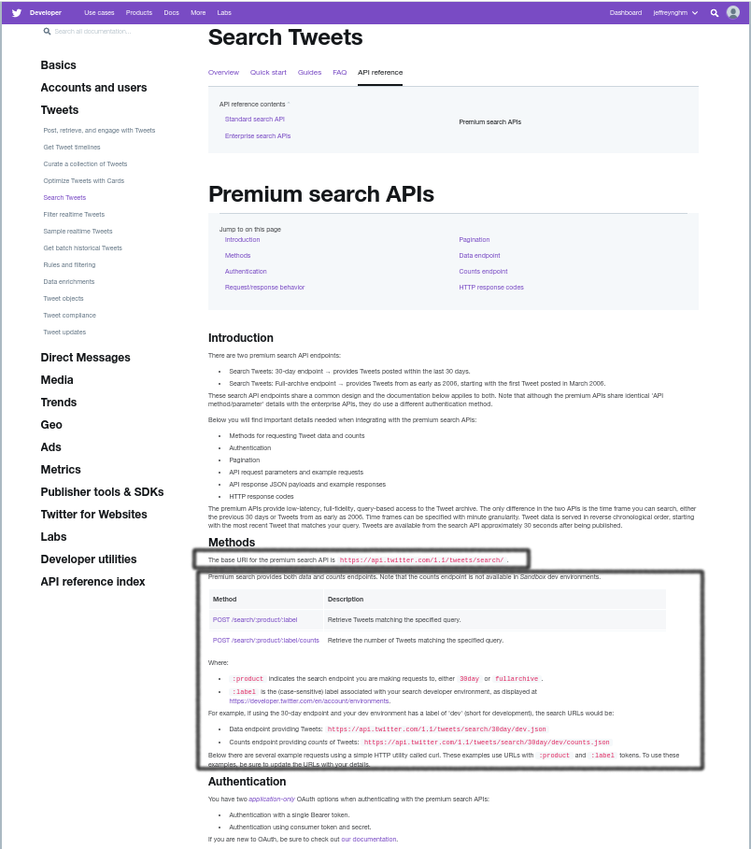

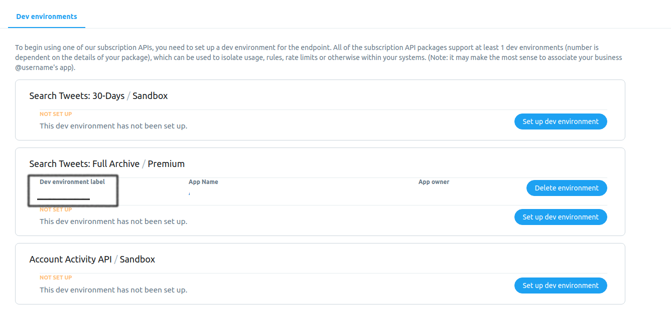Dev environment label: